Agent Drift: Measuring Behavioral Degradation in Multi-Agent Systems

Problem: The paper identifies agent drift as the progressive degradation of behavior, decision quality, and inter-agent coherence that occurs over extended interaction sequences in multi-agent LLM systems.

Solution: The author proposes a stabilization framework utilizing episodic memory consolidation, drift-aware routing protocols, and adaptive behavioral anchoring to maintain system integrity.

Measurement: Progress is quantified through the Agent Stability Index (ASI), a composite metric framework measuring twelve dimensions including response consistency, tool usage patterns, and inter-agent agreement rates.

Impact: Failure to address drift leads to substantial reductions in task accuracy and increased operational costs from higher human intervention requirements, whereas these strategies maintain system throughput and reliability.

Relevance: This work establishes the foundational methodology for monitoring and mitigating drift in production-grade enterprise AI engineering to ensure deployment reliability and safety

Sophia: A Persistent Agent Framework of Artificial Life

Problem: Traditional AI agents are limited by static, reactive architectures that lack the meta-cognitive persistence and intrinsic motivation required to autonomously adapt or maintain identity in non-stationary environments.

Solution: The paper introduces Sophia, a persistent framework that grafts a "System 3" meta-cognitive layer—integrating episodic memory, theory-of-mind, and self-modeling—onto standard LLM stacks to enable self-directed learning and identity continuity.

Measurement Techniques: Performance is quantified by evaluating first-attempt success rates across task complexities, the frequency of autonomous goal generation during idle periods, and the reduction in chain-of-thought reasoning steps for recurring operations.

Scale and Impact: The framework achieved a 40% gain in success for high-complexity tasks and an 80% reduction in reasoning costs for repeating tasks, effectively transforming agents from one-shot executors into efficient, experience-driven learners.

Relevance: This architecture is foundational for Enterprise AI engineering because it provides the meta-cognitive oversight and auditability required to deploy reliable, self-improving agents in high-stakes, dynamic sectors like healthcare insurance

The Dawn of Agentic EDA: A Survey of Autonomous Digital Chip Design

Problem: Abstract, high-level user requests cannot be executed directly by general models because they lack the specialized knowledge required to navigate the proprietary protocols and multi-stage orchestration of complex industrial toolchains. (The paper is about chip design and code generation, but there are a few transferable techniques.)

Solution: The framework employs a hierarchical controller (e.g., AutoMage) that is custom fine-tuned on domain-specific manuals to autonomously decompose natural language intent into executable scripts and task-specific tool calls.

Measurement Techniques: System performance is quantified by the task planning success rate, specifically evaluating the agent's ability to accurately translate complex specifications into valid, multi-step execution sequences.

Scale and Impact: This orchestration methodology achieves a 98.3% success rate in task planning, demonstrating that agents can effectively manage intricate, multi-stage workflows without manual human intervention.

Relevance: For Enterprise AI and healthcare insurance, this architecture provides a blueprint for building agents that can decompose complex policy or claims requests into precise, auditable tool invocations across legacy backend systems while maintaining rigorous execution standards

AI Meets Brain: A Unified Survey on Memory Systems from Cognitive Neuroscience to Autonomous Agents
There are a lot of techniques and content to explore from this paper.

Problem: The paper addresses the fundamental limitation of Large Language Models (LLMs) being natively stateless, which prevents agents from maintaining cross-session continuity or accumulating historical experience required for complex, long-horizon decision-making.

Solution: The authors propose a unified framework that synthesizes interdisciplinary insights from cognitive neuroscience—specifically biological storage mechanisms and memory management lifecycles—to engineer persistent memory systems for autonomous agents.

Measurement Techniques: Evaluation methodology relies on semantic-oriented benchmarks that measure an agent’s internal state maintenance and episodic-oriented benchmarks that assess performance gains in vertical domains such as tool use and environment interaction.

Scale and Impact: Implementing these persistent memory mechanisms transforms agents from one-shot executors into autonomous, experience-driven learners, allowing them to bypass physical context window constraints and achieve deep personalization through dynamic context reconstruction.

Relevance: This research is foundational for Enterprise AI engineering because it provides the architectural blueprint for deploying agents in healthcare insurance that can maintain persistent, auditable patient personas and modularly share specialized domain expertise across heterogeneous organizational systems

https://github.com/LeapLabTHU/ExpeL
https://github.com/TeleAI-UAGI/Awesome-Agent-Memory - Has a collation of techniques with code and papers.
https://arxiv.org/abs/2509.09498

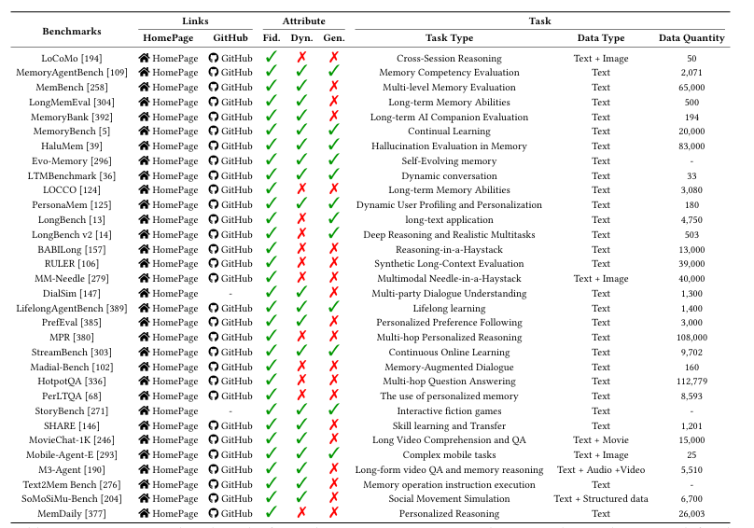

AI Agent Systems: Architectures, Applications, and Evaluation

Problem: Current foundation models lack grounding and reliability for complex, multi-turn tasks, often failing due to hallucinations and an inability to maintain state or execute actions within real-world constraints.

Solution: The paper proposes the agent transformer paradigm, which embeds foundation models into a structured control loop featuring explicit interfaces for memory, tools, and verifiers to transform intent into auditable, multi-step procedures.

Measurement Techniques: Performance is measured via a multi-dimensional framework that tracks end-to-end task success, operational efficiency (cost and latency), tool-selection accuracy, trajectory quality, and robustness under environment variability.

Scale and impact: This architectural shift moves AI from passive chat interfaces to active workflow executors capable of operating across diverse domains, including autonomous coding, enterprise operations, and physical robotics.

Relevance: In enterprise and healthcare settings, this framework enables policy-compliant automation for high-stakes tasks—such as prior-authorization packets and CRM orchestration—by enforcing strict permission gates, auditability, and clinical guideline verification

LLM router: https://github.com/NVIDIA-AI-Blueprints/llm-router

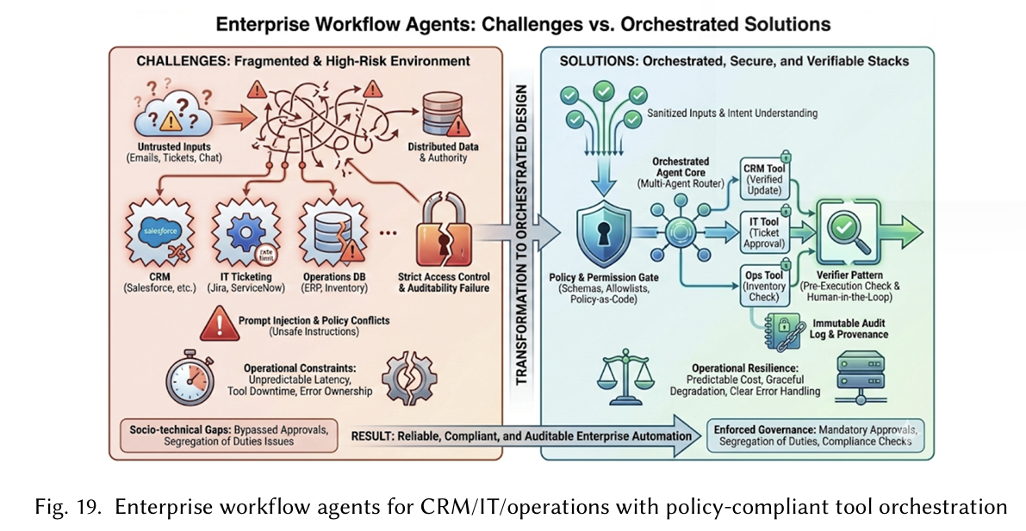

The path Ahead for Agentic AI: Challenges and Opportunities
Problem: The research addresses the transition from passive, one-shot Large Language Models to autonomous systems, aiming to overcome current limitations in reliability, transparency, and the inability to perform multi-step goal pursuit in open-ended environments.

Solution: The paper advocates for an "Agentic AI" framework that integrates LLMs as cognitive engines within a closed-loop architecture featuring explicit perception, persistent memory, tool execution, and iterative reason-act-reflect cycles.

Measurement Techniques: Evaluation shifts from simple text metrics to team-based performance indicators like throughput and auditability, while identifying critical performance gaps through specialized benchmarks where current models achieve only 30% accuracy on culturally grounded reasoning compared to human experts.

Scale and impact: This shift transforms AI from a conversational interface into a goal-directed collaborator capable of autonomous operations across multidisciplinary fields, including research automation, education, and physical robotics.

Relevance: For high-stakes enterprise and healthcare insurance environments, the framework provides a roadmap for policy-compliant automation through structured guardrails, mandatory auditability logs for every action taken, and human-in-the-loop checkpoints for high-impact clinical or financial decisions.

SimpleMem: Efficient Lifelong Memory for LLM Agents

Problem: Current LLM agents struggle with "context inflation" and redundancy during long-term interactions, leading to prohibitive computational costs and reasoning degradation known as the "lost-in-the-middle" effect.

Solution: The authors propose SimpleMem, a three-stage framework that optimizes token utilization and accuracy through semantic structured compression, recursive memory consolidation, and adaptive query-aware retrieval.

Measurement Techniques: The system is evaluated on the LoCoMo benchmark using F1 and BLEU scores to test multi-hop and temporal reasoning, alongside metrics for token cost, construction time, and retrieval latency.

Scale and Impact: SimpleMem achieves a state-of-the-art 26.4% F1 improvement over existing memory systems while reducing inference-time token consumption by up to 30x, enabling lightweight 3B-parameter models to outperform much larger flagship models.

Relevance: The framework provides a scalable architecture for high-stakes domains like healthcare insurance by utilizing temporal normalization and coreference resolution to transform messy, multi-session "patient" or "client" histories into precise, auditable, and cost-efficient factual records.

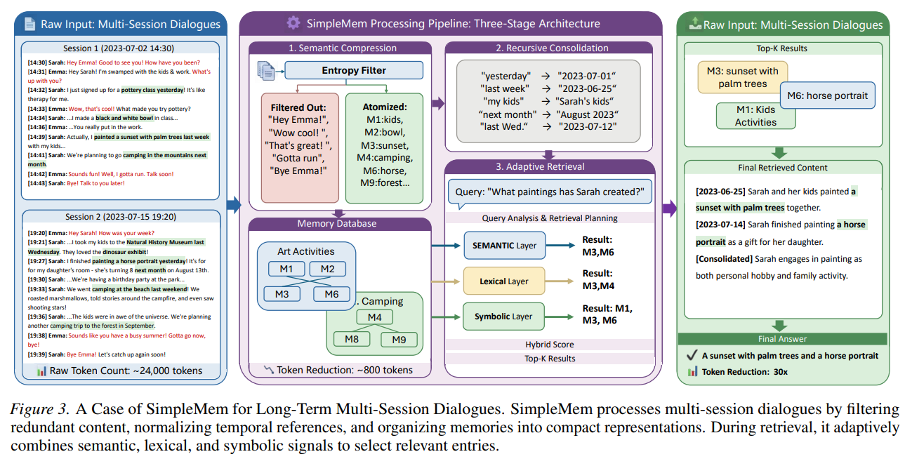

ART: Adaptive Reasoning Trees for Explanable Claim Verification

Problem: Large Language Models (LLMs) currently lack the transparency, faithfulness, and accountability required for high-stakes, truth-sensitive decision-making due to their inherent opacity and susceptibility to hallucinations.

Solution: The paper introduces Adaptive Reasoning Trees (ART), a framework that utilizes hierarchical argument generation, pairwise tournament ranking, and Bradley-Terry strength calibration to systematically derive transparent and contestable verdicts.

Measurement Techniques: Performance is evaluated through accuracy benchmarks on the MedQA, StrategyQA, and TruthfulQA datasets, alongside quantitative assessments of decision-trace faithfulness and strength-calibration variance.

Scale and Impact: ART achieves state-of-the-art accuracy and establishes a scalable framework for moving AI from unfaithful "black-box" rationalizations to auditable, bottom-up reasoning architectures suitable for specialized domains like medicine and law.
Relevance: In healthcare insurance and enterprise engineering, this framework enables the deployment of auditable, policy-compliant systems for high-stakes tasks such as medical claim verification—where decisions must be justified, traceable, and open to contestation.

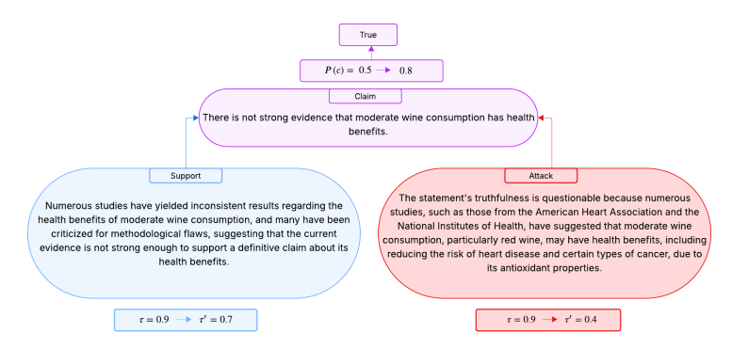

A Critical Analysis of the Medibank Health Data Breach and Differential Privacy Solutions
https://arxiv.org/pdf/2601.03508

Problem: The research addresses the critical vulnerability of centralized healthcare data systems to catastrophic breaches and re-identification caused by the lack of privacy-preserving analytics and the unencrypted storage of high-entropy medical records.

Solution: The authors propose a multi-layered security framework that integrates an entropy-aware differential privacy (DP) system—utilizing Laplace, Gaussian, and exponential mechanisms—with a zero-trust architecture featuring structural data segmentation and role-based access.

Measurement Techniques: System effectiveness is quantified through a multi-faceted evaluation of re-identification probability reduction, analytical utility loss, and statistical distribution stability measured via Kullback–Leibler (KL) and Jensen–Shannon (JS) divergence.

Scale and Impact: The framework demonstrates a 90.3% reduction in re-identification risk while keeping analytical utility loss below 24%, establishing a scalable, regulation-ready paradigm for protecting sensitive datasets involving millions of individual records.

Relevance: For enterprise AI engineering in healthcare insurance, this research provides a technical blueprint for regulation-ready medical analytics that mitigates "harvest now, decrypt later" quantum threats and satisfies strict compliance mandates such as GDPR Article 32 and Australian Privacy Principle

SciClaims: An End-to-End Generative System for Biomedical Claim Analysis
Problem: The manual validation of assertions in Systematic Literature Reviews (SLR) is a labor-intensive, error-prone process that currently fails to scale alongside the exponential growth of biomedical publications.

Solution: The paper introduces SciClaims, an end-to-end generative pipeline that integrates claim extraction, PubMed evidence retrieval, and veracity verification into a single, seamless LLM-driven workflow.

Measurement Techniques: System performance is rigorously assessed through SciFact benchmarks, LLM-as-a-judge evaluations of claim quality and retrieval recall, and human expert reviews of label accuracy and rationale transparency.

Scale and Impact: Optimized for a single 24GB GPU, the system enables real-time, high-throughput analysis across 4.7 million curated PubMed abstracts, democratizing access to complex scientific reasoning for researchers and clinicians.

Relevance: For Enterprise AI and healthcare insurance, this provides a low-infrastructure, auditable framework for automating high-stakes tasks such as pharmaceutical patent validation, clinical decision support, and regulatory submission reviews

Code: https://github.com/siftech/SciClaim

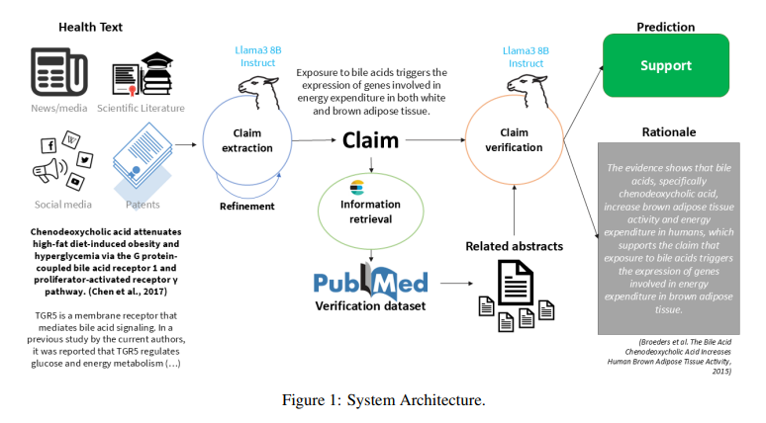

An Attack Method for Medical Insurance Claim Fraud Detection based on Generative Adversarial Network
https://arxiv.org/pdf/2506.19871

Problem: Current AI-driven insurance fraud detection systems are highly vulnerable to sophisticated adversarial threats due to a lack of standardized defense mechanisms and the ability of attackers to manipulate structured claims data.

Solution: The paper proposes a novel Generative Adversarial Network (GAN) framework optimized via reinforcement learning and surrogate models to generate deceptive fraudulent cases that can bypass detection systems with minimal access to real data or internal model details.

Measurement Techniques: System vulnerability is quantified using Attack Success Rate (ASR), Accuracy, and F1 scores, with performance benchmarks conducted through the Adversarial Robustness Toolbox (ART) against traditional gradient-based attack methods.

Scale and Impact: The proposed method achieved an Attack Success Rate of 99% against both LSTM and XGBoost models, demonstrating a critical systemic risk that could lead to significant financial losses within the multi-trillion-dollar healthcare industry.

Relevance: This research serves as a high-priority warning for Enterprise AI engineering in healthcare insurance to move beyond standard ML models toward robust adversarial training and uncertainty-aware architectures to safeguard against automated fraud.

Device-Native Autonomous Agents for Privacy-Preserving Negotiations
https://arxiv.org/pdf/2601.00911

Problem: Automated negotiations in insurance and B2B commerce currently force a trade-off between user convenience and data privacy by requiring sensitive financial constraints to be processed on centralized servers.

Solution: The authors propose a device-native agentic AI system that integrates distilled world models for on-device reasoning, zero-knowledge proofs for private bilateral bargaining, and cryptographic explainable memory for verifiable audit trails.

Measurement Techniques: The system is evaluated based on negotiation success rates, end-to-end latency, energy consumption, Nash bargaining fairness scores, and bits of information exposed through cryptographic leakage.

Scale and Impact: The framework achieves an 87% average success rate and a 2.4x latency improvement over cloud-based baselines while reducing sensitive data exposure by approximately 94%.

Relevance: This architecture provides a blueprint for enterprise AI engineering to deploy secure, policy-compliant autonomous agents capable of handling sensitive insurance premium negotiations and claims settlements directly on consumer hardware.

Architecting Agentic Communities using Design Patterns: A Framework Grounded in ODP Enterprise Language Formalism

Problem: The research addresses the critical lack of systematic architectural guidance and formal governance required to deploy autonomous AI agents safely and accountably in complex, multi-participant enterprise environments.

Solution: The authors propose a three-tier architectural framework—comprising LLM Agents, Agentic AI, and Agentic Communities—that utilizes 46 design patterns grounded in the ISO Open Distributed Processing (ODP) Enterprise Language to ensure verifiable coordination between AI and humans.

Measurement Techniques: System effectiveness is validated through a clinical trial matching case study and the formal verification of safety, authority, and accountability properties using deontic tokens to track obligations, permissions, and prohibitions at runtime.

Scale and Impact: By organizing patterns into 12 thematic categories, the paper provides a scalable roadmap to transition AI from simple task-specific automation into production-grade, multi-agent ecosystems capable of driving measurable operational improvements in asset-intensive and regulated industries.

Relevance: This framework is highly relevant to enterprise AI engineering and healthcare insurance because it enables the deployment of policy-compliant automation for high-stakes tasks—such as claims processing or patient matching—by enforcing mandatory human-in-the-loop oversight and traceable, auditable decision chains.
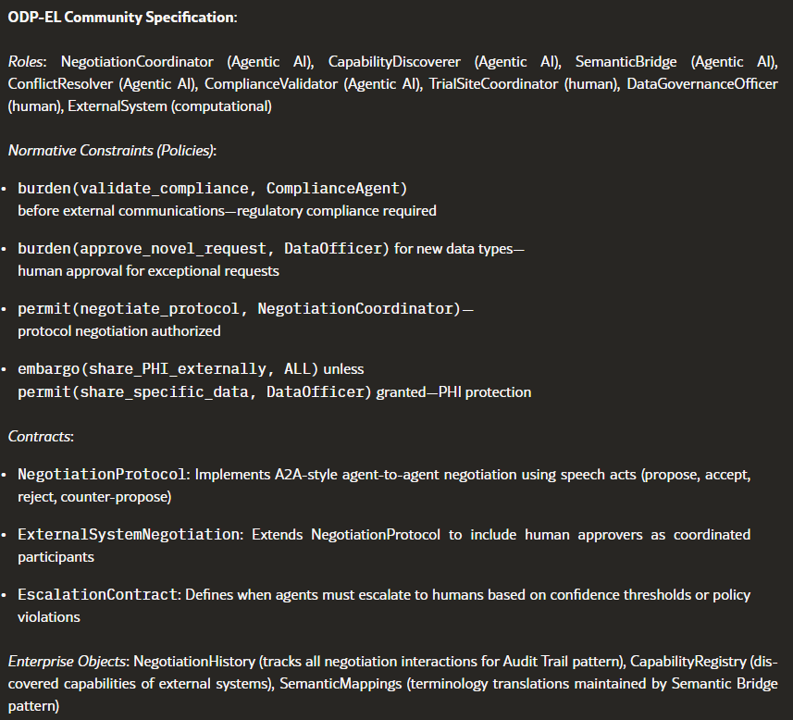

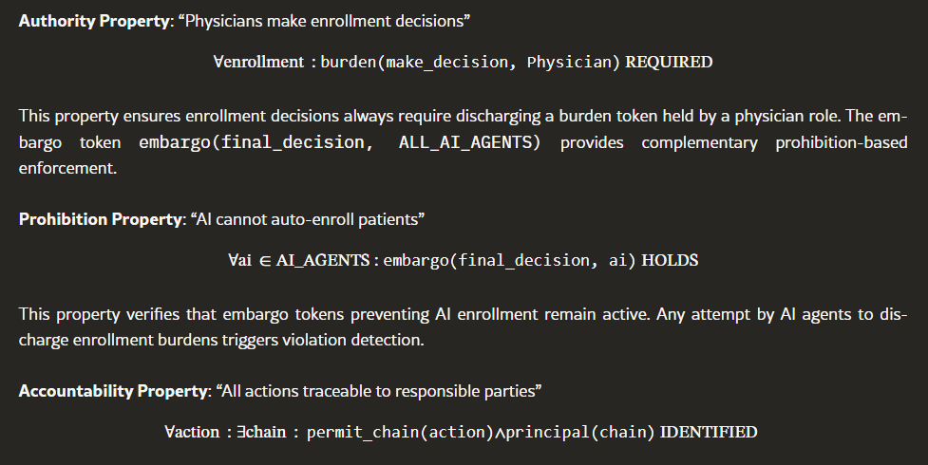

Medusa: Cross-Modal Transferable Adversarial Attacks on Multimodal Medical Retrieval-Augmented Generation
https://arxiv.org/abs/2511.19257

Problem: Multimodal medical retrieval-augmented generation (MMed-RAG) systems used in clinical decision support are highly vulnerable to adversarial visual perturbations that can hijack the retrieval process and compromise medical outputs.

Solution: The authors developed Medusa, a black-box framework that uses multi-positive InfoNCE loss, surrogate model ensembles, and dual-loop optimization to align adversarial images with medically plausible but malicious textual targets.

Measurement Techniques: The framework's efficacy is quantified by the Attack Success Rate (ASR) across various retrievers and generation models during real-world tasks like disease diagnosis and medical report generation.

Scale and Impact: Medusa achieves an average attack success rate of over 90% and remains effective against four mainstream defenses, exposing critical security flaws in safety-critical medical AI applications.

Relevance: For enterprise AI engineering and healthcare insurance, this research highlights the urgent necessity for robustness benchmarking and defensive hardening of RAG-based systems to prevent adversarial exploitation in sensitive clinical and financial environments

